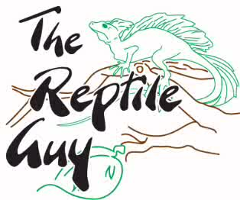

Owning a pet of any kind is a huge responsibility. You must be able to provide your new pet everything it needs for its ENTIRE life. Things your pet will need include a variety of food, water, suitable sized enclosure, enrichment items such as hides and branches, heating pads/lights, UV lights and possible veterinary care. If you cannot afford these items or you do not have time for your new pet you should reconsider your choice of adopting. It is not fair to the animal to be put into a situation where it will not be properly cared for.
Please do plenty of research before applying to adopt a reptile and make sure that this is a suitable pet for your budget and lifestyle.

The Reptile Guy does not want any rescues or surrenders being adopted for breeding purposes. There are far too many unwanted reptiles that already need homes. There is no need to make more.

Must be at least 19 years of age to adopt.

Please answer the following questions

1. What are you applying to adopt?

_________________________________________________________________________

2. Have you ever owned an exotic pet in the past? If yes, what species?

_________________________________________________________________________

3. How large are you expecting your new pet to grow?

_________________________________________________________________________

3. What will you be feeding your new pet?? (please be as specific as possible)

_________________________________________________________________________

4. Where will you purchase your new pets food?

_________________________________________________________________________

5. Where will you take your new pet in the case of a medical emergency? (Name of Veterinarian)

_________________________________________________________________________

6. How long are you expecting your new pet to live?

_________________________________________________________________________

7. What are the dimensions of your new pets enclosure?

_________________________________________________________________________

8. How are you securing the enclosures lid/door so that the snake cannot escape?

_________________________________________________________________________

9. What type of heating system do you have in place for your enclosure?

_________________________________________________________________________

10. What is the basking temperature/cool side temperature in the enclosure?

_________________________________________________________________________

11. Is your new pet legal in the city you live in? You can find city bylaws information online.

_________________________________________________________________________

12. Are you planning on using your new pet for breeding purposes?

_________________________________________________________________________

Please attach pictures of your enclosure with your completed application. Applications can be emailed to mike@reptileguy.ca.

If for any reason you can no longer care for your reptile, you are strongly encouraged to return it to The Reptile Guy so that a new suitable home can be found.

By signing below, you are assuring The Reptile Guy that you have answered all of the above questions truthfully.

Full Name Phone Number Age

_________________________________________________________________________

Address

_________________________________________________________________________

Signature

_____________________________________

